Diabetes Health Risk Analysis Dataset Clinical and lifestyle factors associated with diabetes status.
1. Project Overview and Objective

This project involves cleaning, transforming, and analysing diabetic health and lifestyle data using Python and creating interactive Power BI dashboards to derive meaningful health insights.
The main objective is to analyse key health and lifestyle factors associated with diabetes and present meaningful patterns using interactive Power BI dashboard visualizations.
2. Data Sources (Sample)
- Source Description and Timeline: Diabetic Health Dataset / 5000 Patient Records.
- Domain: Healthcare / Diabetes / Health and Lifestyle Analytics.

3. Problem Statement (Sample)
- To analyse health factors such as glucose, insulin, BMI, age, and heredity to identify patterns associated with diabetes.
- To study lifestyle factors such as exercise, diet, smoking, alcohol, stress, and sleep for better understanding of diabetic health patterns.
- To evaluate relationships between health and lifestyle factors across diabetic and non-diabetic patient groups.
- To understand key factors associated with diabetes status and provide meaningful insights through Power BI dashboards.

4. Attribute (Column /Features) Details: (Sample)
Attribute Name | Data Type | Description
Glucose | Float | Blood glucose level of patient
BMI | Float | Body mass index of patient
Insulin | Float | Blood insulin level of patient
Age | Integer | Individual age of patient
Gender | String | Individual gender of each patient
Diet Type | String | Type of diet
Exercise Frequency | String | Exercise frequency level of patient
Heredity | String | Family diabetes history of patient
Smoking | String | Smoking status of patient
Alcohol | String | Alcohol consumption of patient
Stress Score | Float | Individual stress level of patient
Sleep Hours | Float | Daily sleep duration of patient
Diabetes Status | String | Diabetes classification status
Glucose Group | Category | Blood sugar level group
Insulin Group | Category | Insulin concentration level group
Age Group | Category | Age range
BMI Group | Category | Body mass index group

5. Tools & Technologies
- Excel: Data cleaning, transformation, and Pivot Tables.
- Power BI: Data modelling, DAX calculations, visualization, and interactive dashboard creation.

6. Data Pre-Processing (Pandas Cleaning)
Tasks Performed:
- Data Cleaning & Transformation: handled missing values, standardized formats, and created grouped median for glucose, BMI, Insulin and Age.
- Changed the data type of age from float to integer.
- I take mode for categorial vales and median for stress score and sleep hours and for diabetes status I filled with unknown because it is an important feature.

7. Visualization
Pie Chart: Diabetes Status Distribution
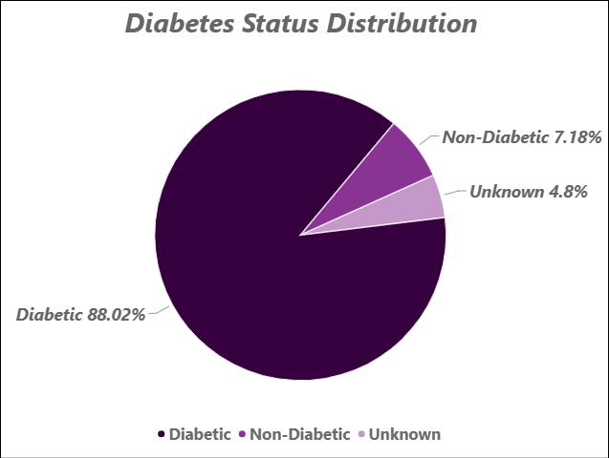
- Diabetic patients form the majority at 82.02%. Non-diabetic patients account for 7.18%. 4.8% of records have an unknown status. The dataset is highly dominated by diabetic cases.
Line Chart: Median Glucose Vs Age Group by Diabetes Status
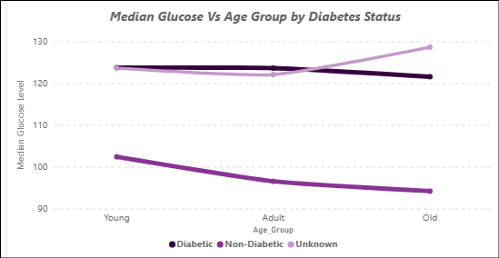
- Diabetic patients consistently show higher median glucose levels across all age groups, while non-diabetic patients have lower levels, indicating that glucose is more strongly associated with diabetic status than age.
Scatter Chart: Glucose Vs Insulin by Diabetes Status
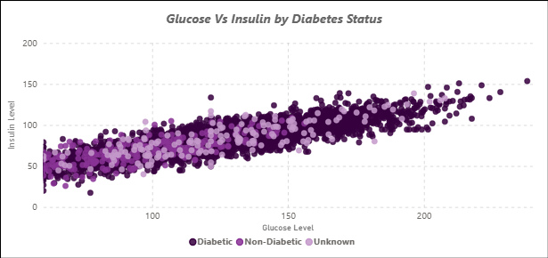
- Glucose and insulin show a strong positive relationship, where insulin levels generally increase as glucose levels increase. This indicates a clear association between blood glucose levels and insulin levels in the dataset.
Scatter Chart: Glucose Vs BMI by Diabetes Status
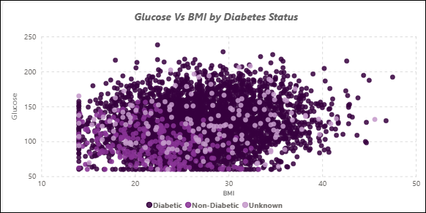
- Diabetic patient are spread across almost the entire BMI and Glucose range, while Non Diabetic patients cluster more toward lower BMI and lower Glucose values. Since 88% of the dataset is diabetic, the chart is naturally dominated by blue points, so this imbalance should be kept in mind when interpreting the pattern
Clustered Column Chart: Heredity by Diabetes Status
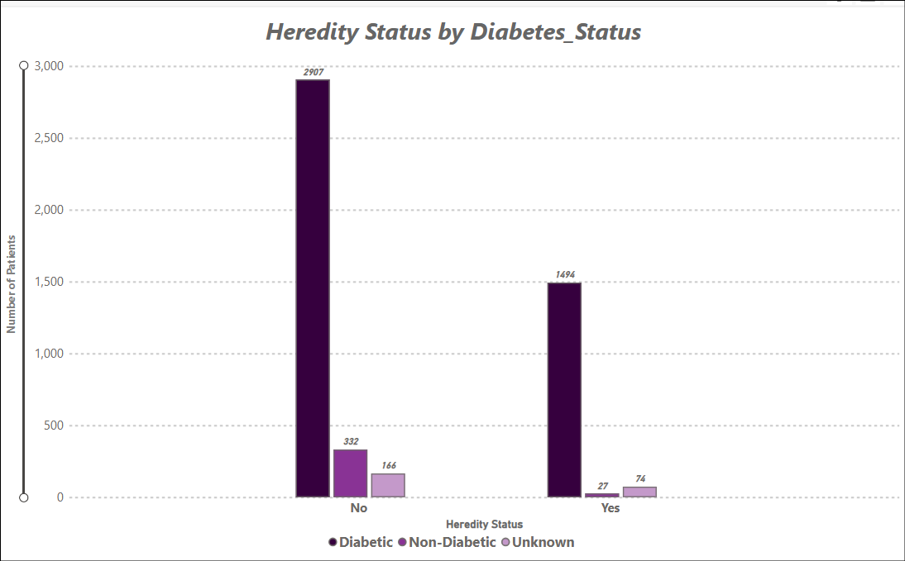
- This chart shows how diabetes status is distributed among patients with and without family history, helping us compare the number of diabetic and non-diabetic patients across the two groups. It shows an association between family history and diabetes status, not that family history directly causes diabetes, As a dataset finding.

Clustered column Chart: Exercise frequency by diabetes status
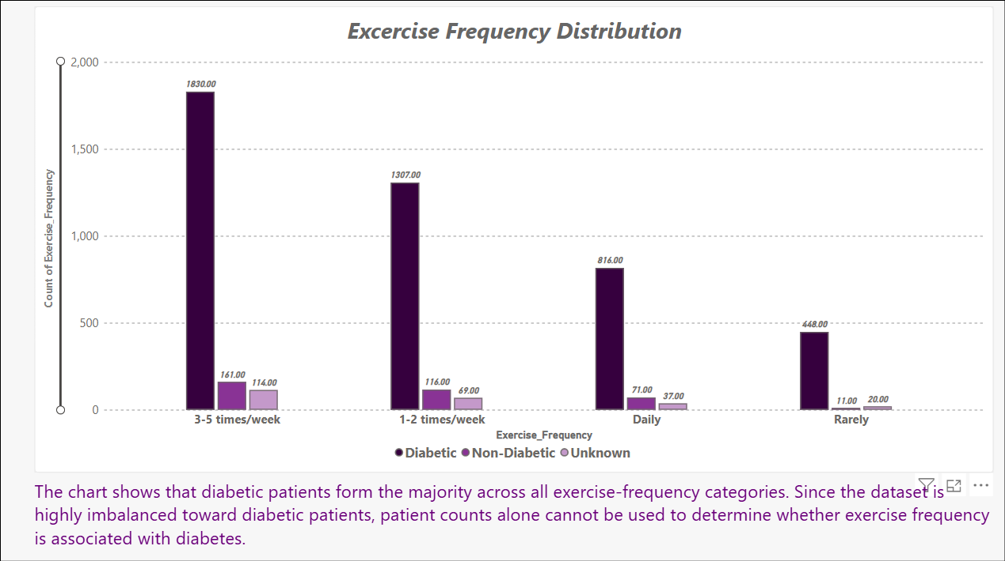
Clustered column Chart: Exercise frequency by diabetes status

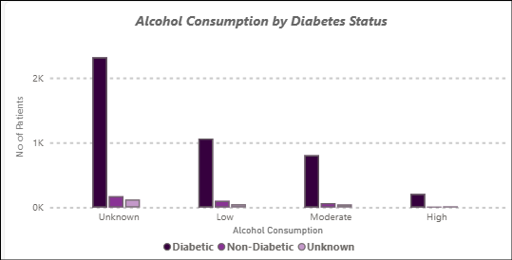
Diabetic patients are more numerous than non_diabetic patients across all recorded alcohol-consumption categories. However, because the number of patients varies considerably between categories and many alcohol values are unknown, no clear relationship between alcohol consumption level and diabetic status can be concluded from this chart alone.

Stacked column Chart: Diet type by diabetes status
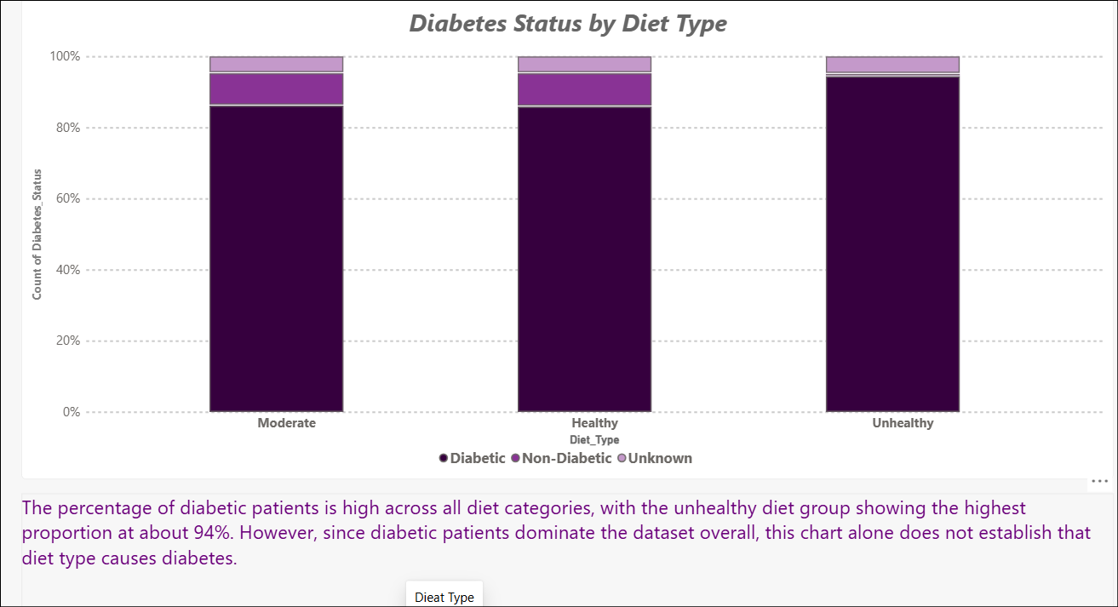
Stacked column Chart: Diet type by diabetes status
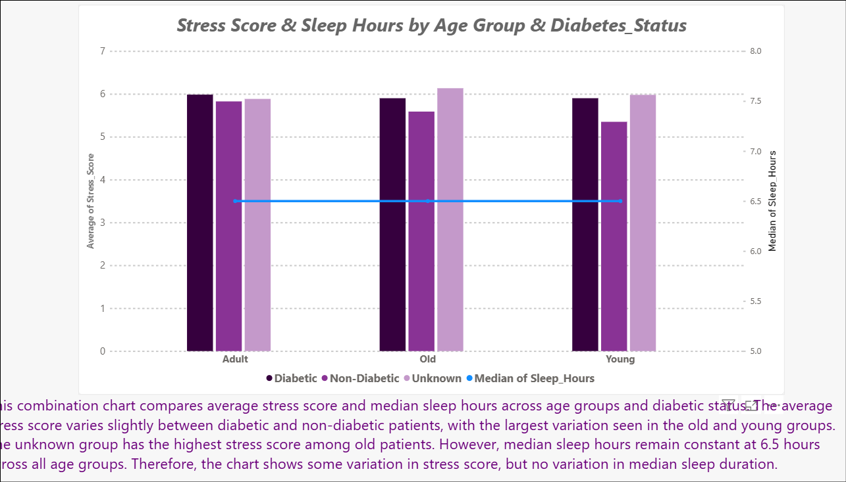

8. Analysis and Visualizations (Power BI)
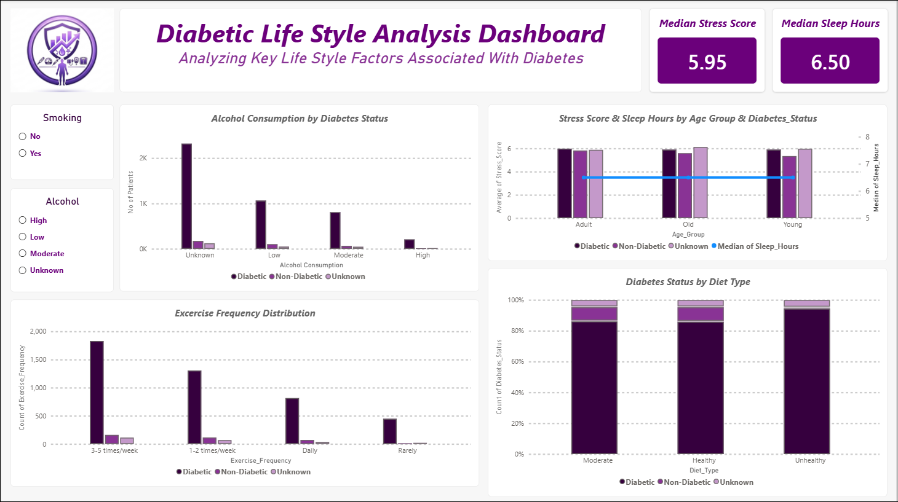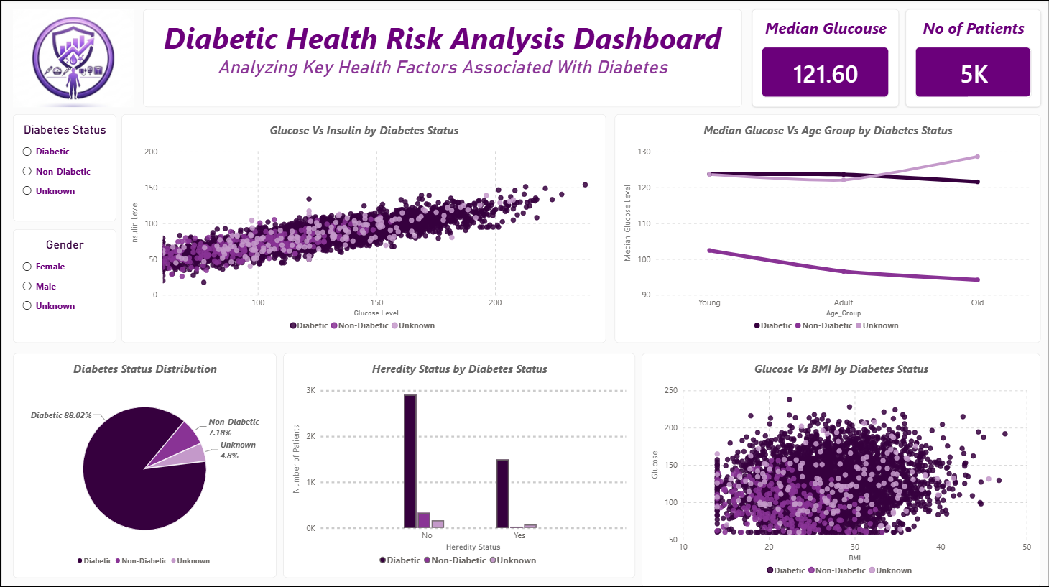

9. Insights & Conclusions
Dashboard 1 – Risk Factor Analysis
KEY INSIGHTS
- Higher glucose levels are more commonly observed among diabetic patients.
- Glucose and insulin show a strong positive relationship.
- BMI shows a weaker positive association with glucose levels.
- Heredity Status shows differences between diabetic and non-diabetic patient groups.
- The dataset has a higher proportion of diabetic patients than non-diabetic patients, so comparisons based on patient counts should be interpreted with caution.

Dashboard 2 – Lifestyle Analysis
KEY INSIGHTS
- Diabetic patients form the largest group across all exercise-frequency categories.

- Diet categories do not show a sufficiently clear pattern across diabetic status.
- Smoking and alcohol consumption do not show a strong or consistent pattern with diabetic status.
- Stress scores show only small variations across age groups and diabetic status.
- Median sleep duration remains at 6.5 hours across all age groups.

Overall Key Insights
- Glucose, insulin, and BMI show the clearest patterns in the diabetes analysis, with glucose and insulin having the strongest observed relationship.
- Lifestyle factors show weaker and less consistent patterns compared with the main health-related factors.
- The analysis suggests that glucose, insulin, and BMI are important indicators for further investigation. However, this analysis alone should not be used to make medical decisions
10. Conclusions (Sample)
The analysis shows that glucose, insulin, and BMI are the key factors associated with diabetic status in the dataset. Diabetic patients generally have higher glucose and insulin levels, while glucose and insulin also show a strong positive relationship. Age, lifestyle factors, and other demographic factors show comparatively weaker associations in this dataset. Overall, the analysis helps identify the major patterns and risk-related factors associated with diabetes and provides useful insights for further monitoring and decision-making.

